

DLD Lab-06

Subtractor



NATIONAL UNIVERSTIY OF COMPUTER AND EMERGING SCIENCES, FAST- Peshawar Campus

Department Of Computer Science

Instructor: Engr. Waseem Ullah

EL1005 – Digital Logic Design-Lab

SEMESTER SPRING 2022

Contents

1. Objectives: 2

2. Equipment Required: 2

3. What is Subtractor ? 2

4. Half subtractor 2

5. FULL Subtractor 3

6. K-Map Minimization 4

7. Applications 5

# Objectives:

To become familiar with the operation of adders and Subtractors

# Equipment Required:

* DEV-2765E Trainer Board/ Multisim 14.2 /Logic.ly
* 7486 quad 2-input XOR gate IC
* 7404 Hex Inverter gate IC
* 7408 quad 2-input AND gate IC
* 7432 quad 2-input OR gate IC

# What is Subtractor ?

Subtractor is an electronic logic circuit for calculating the difference between two binary numbers which provides the difference and borrow as output.

# Half subtractor

Half Subtractor is used for subtracting one single bit binary number from another single bit binary number.It has two inputs; Minuend (A) and Subtrahend (B) and two outputs; Difference (D) and Borrow (Bout).

* 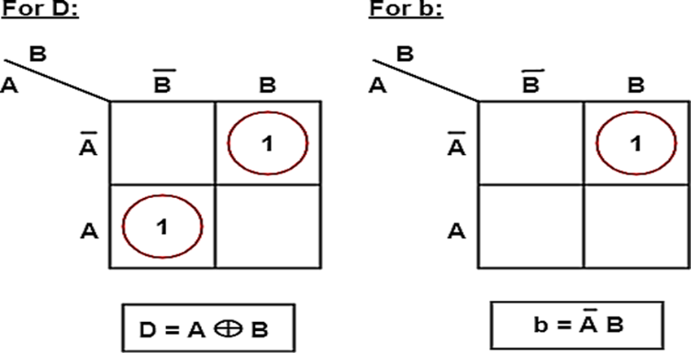T**ruth Table**

**Difference = A ⊕ B**

**Difference = A ⊕ B**

|  |  |  |  |
| --- | --- | --- | --- |
| Input | | Output | |
| A | B | Difference (D) | Borrow (Bout) |
| 0 | 0 | 0 | 0 |
| 0 | 1 | 1 | 1 |
| 1 | 0 | 1 | 0 |
| 1 | 1 | 0 | 0 |

From the truth table and K-map, the Boolean Expression can be derived as:

**Difference (D) = A'.B + A.B'**

**A'.B + A.B**' **= A** ⊕ **B**

**Borrow** (Bout)= **Ā.B**

# FULL Subtractor

A logic Circuit Which is used for subtracting three single bit binary numbers is known as Full Subtractor.

It has three inputs; Minuend (A), Subtrahend

(B) and following Subtrahend (C) and two outputs; Difference (D) and Borrow (Bout).

* **Truth Table**

|  |  |  |  |  |
| --- | --- | --- | --- | --- |
| Input | | | Output | |
| A | B | B(in) | D | B(out) |
| 0 | 0 | 0 | 0 | 0 |
| 0 | 0 | 1 | 1 | 1 |
| 0 | 1 | 0 | 1 | 1 |
| 0 | 1 | 1 | 0 | 1 |
| 1 | 0 | 0 | 1 | 0 |
| 1 | 0 | 1 | 0 | 0 |
| 1 | 1 | 0 | 0 | 0 |
| 1 | 1 | 1 | 1 | 1 |

* **Solving Truth Table using K-Map**

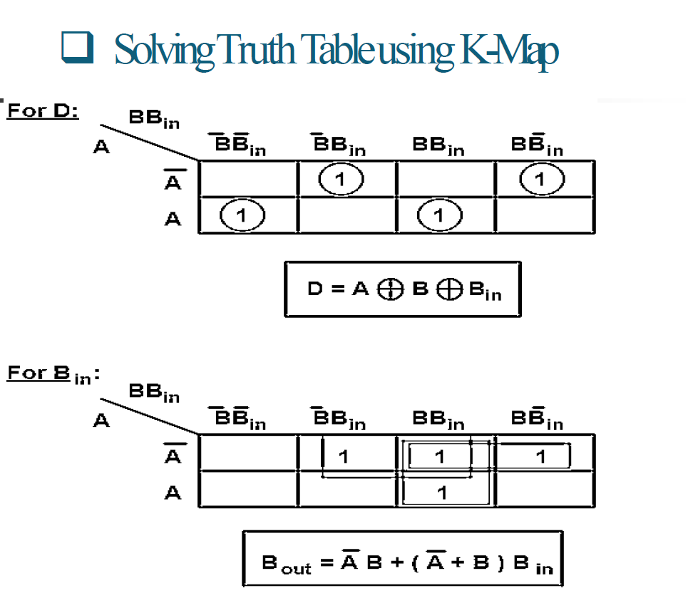

# K-Map Minimization

From the Truth Table The Difference and Borrow will written as,

Difference=A'B'C+A'BC'+AB'C'+ABC

Reducing it we got, Difference=A ⊕B ⊕C

Borrow=A'B'C+A'BC'+A'BC+ABC

=A'B'C+A'BC'+A'BC+A'BC+A'BC+ABC

=A'C(B'+B)+A'B(C'+C)+BC(A'+A) Borrow=A'C+A'B+BC

From the truth table and k-map minimization, the Boolean Expression can be derived as:

**D = A** ⊕ **B** ⊕ **C**

**B(out)** = **BC + (B** ⊕ **C) A**

# Applications

* To attenuate the radio/audio signal
* In amplifier to reduce sound distortion
* In arithmetic logic unit of processors
* Increment and decrement operators
* Calculate addresses

# Lab Task

1. Design and implement the circuitry for a Half subtractor.
2. Implement a half subtractor using AND, OR and NOT gates only.
3. Implement a half subtractor using IC-74LS139.
4. Design and implement the circuitry of a full subtractor.